~ Aron the Excapist ~

A TextAdventure Game

User Guide

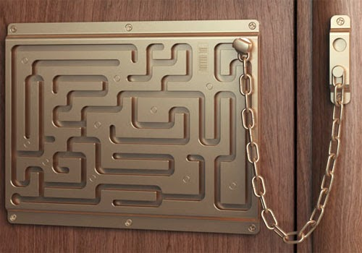

User Guide by: Winnie

Game Created by: Kajal, Kathy and Winnie

Introduction

The main character is Aron who works for the FBI. At the start of the game, he gets kidnapped by seemingly a secret society of vigilantes who works for the Russians. Aron must use resources that he finds in order to help escape each room. What he doesn’t know is that at the end, Aron gets told that it was all a big test by his organization to prove his loyalty and reliability.

Walkthrough

Captivity Room

The main character, Aron, first wakes up and finds himself in an unknown room on a bed with handcuffs around his wrists. There are glass walls surrounding the room as well as four doors in each direction. In front of the bed is a table with two notes, one indicating instructions to the player on how to play and another stating that the key to unlock the handcuffs are in the second drawer of the table. In order to open the drawer, the player must trade in Aron’s necklace that he is wearing. The player will also need to find a backpack that will act as an inventory in the room.

Dragon Room

The door towards the south leads to a room that is dragon themed. There the player first finds a note in which Aron can obtain a jewel, a dragon tooth and a torch.

Egyptian Room

The door towards the west is Egyptian themed and has tombs along the sides of the room and a sphinx statue in the center. The player must first obtain a torch in order to go into the mummies tomb. A jewel must also be exchanged in order to evade the curse of entering an Egyptian lair. Aron can obtain gold coins and a mummy’s head piece.

High Tech Room

The door towards the east leads into a very high tech room with various robots. Rows of computers are seen as well as flying cars in the background outside of the windows. Player can either trade in gold, jewel or medallion to evade the laser surveillance system. Aron can obtain a shield, usb drive and a universal key in this area.

Ninja Room

The door towards the north is Ninja themed and is in a dojo room and has various ninja weapons up on the walls for display. There is only one door enclosed that leads to the next room. Here, the player can obtain a medallion and a shuriken (Japanese throwing star). The shield can be used or the player can choose to trade in gold or jewel to avoid the ninjas.

Pirates Room

The next room is pirates themed and is located in a dark cave with all sorts of coins and treasures strewn around and piled up on the floor. Player must either use a torch in order to navigate around the room or trade in the shield or gold to gain night vision. Here, Aron can obtain a treasure box, eye patch and a pet parrot. However, in order to go to the next room Aron must crack the puzzle on the treasure box and open it to get the code to open the door.

Prison Room

The next room is a dimly lit prison room with bars encasing around him with a cell door that is locked. Running along a straight and horizontal corridor towards each wall lies a door to the next few rooms. Here the player can find a paper clip and a prisoner’s clothes. The paper clip must be used to lock pick the locked cell door.

Botanical Garden

The door to the west of the prison room leads toward a botanical garden. Patches and bushes of various plants and flowers run along the pathway towards a giant Venus fly trap in the center of the garden. Here the player can either choose to release the pet parrot or trade in the paper clip for glasses.

Indoor Pool Room

The door to the east of the prison room leads to a room in which there is a large pool in the center with a suitcase vaguely seen at the bottom of the pool. Aron must change into the prisoner’s clothes in order to get to the suitcase. After retrieving it, Aron must change back into his original clothes to move onto the next room.

Ancient Library Room

The door to the north of the prison room leads to an ancient library where bookcases are lined up against the back wall as well as a large window in the center of the wall. The player must find a trap door in which it must first be deciphered on the book that is in the suitcase as well as pulling out a specific book from one of the bookshelves. Once the code is deciphered, the bookcases will move to reveal a locked door that asks Aron for the information USB drive. Once the USB drive is inserted into the space provided for it, the door swings open and Aron is free to go!

List of Commands

Look: Would be able to read notes and other objects that require inspection

Take: In order to use objects that are found, they must be picked up to be put into Aron’s inventory

Use: Found objects can be implemented for different purposes to progress the game

Open: To interact with specific items

Close: To interact with specific items

Go: To move from room to room

Trade: Some items may be exchanged for others or to gain a temporary ability

Wear: Specific clothes or accessories may be worn

Inventory Items

Aron’s Necklace: Must be exchanged to gain access to key

Jewel: Can be exchanged

Dragon tooth: An inventory item

Torch: A useful light source

Gold coins: Can be exchanged

Mummy’s Headdress: A wearable item

Shield: Used to evade certain obstacles

USB drive: Can be used to gain entry

Universal Key: Can be used to gain entry

Medallion: Can be exchanged

Shuriken: An inventory item

Treasure box: A chest with a code inside

Eyepatch: A wearable item and can be exchanged

Prisoner’s clothes: A wearable item

Paper clip: Useful with lockpicking and can be exchanged

Parrot: A pet to accompany with you and can be set free in a specific room

Suitcase: Has a code to decipher inside